HARDWARE COMPONETS
Q1. Draw a labelled diagram of a desktop PC, clearly marking the motherboard, CPU, RAM, GPU, and both HDD and SSD storage components.
ANS.
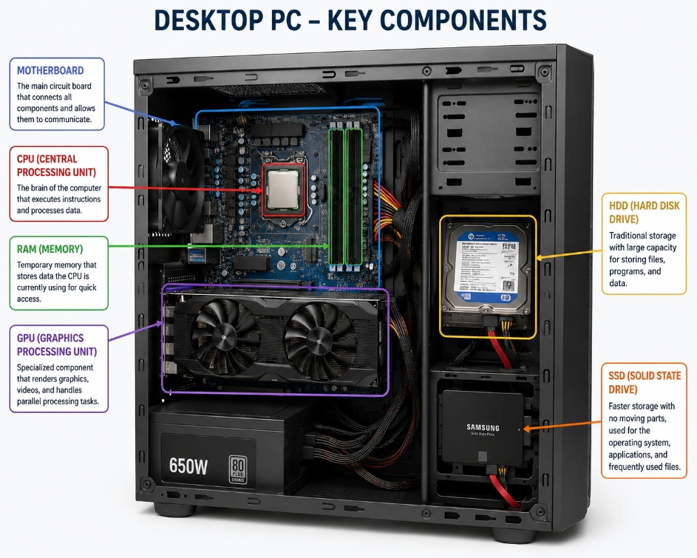
- Motherboard: The main circuit board that connects all computer components and enables communication between them.

- CPU (Central Processing Unit): The brain of the computer that processes instructions and performs calculations.

- RAM (Random Access Memory): Temporary memory that stores data and programs currently being used by the CPU.

- GPU (Graphics Processing Unit): Handles graphics processing and improves performance for gaming, video editing, and 3D applications.
- HDD & SSD: The HDD provides large-capacity storage for files, while the SSD offers much faster storage and quicker system performance

Q2. Create a comparison table showing the main differences between HDD and SSD storage in terms of speed, durability, and typical use cases.<br><br><em><strong>Hint:</strong> Think about which one is faster, which is more shock-resistant, and where you would usually find each type (laptop, gaming PC, etc.).</em>
ANS.
Feature | HDD (Hard Disk Drive) | SSD (Solid State Drive)
Speed | Slower read/write speed | Much faster read/write speed
Durability | Less durable because it has moving parts | More durable and shock-resistant because it has no moving parts
Storage Capacity | Larger storage at a lower cost | Smaller storage is usually more expensive
Power Consumption | Uses more power | Uses less power, improving battery life
Noise | Produces noise due to spinning disks | Silent operation
Typical Use Cases | Desktop PCs, backup storage, file servers | Laptops, gaming PCs, high-performance computers, and operating system drives
Best For | Storing large amounts of data at a low cost | Fast boot times, quick application loading, and better overall performance

Q3. Write a short explanation (2-3 sentences each) describing the role of the CPU, RAM, and GPU in running a game like PUBG or Free Fire on a PC.
ANS.
- CPU (Central Processing Unit):-
- The CPU processes game instructions, controls player actions, and manages game logic. A faster CPU helps the game run smoothly with fewer delays.
- The CPU is the brain of the computer that processes all game instructions and calculations. It controls player movements, game logic, and communication between hardware components. A faster CPU helps games like PUBG or Free Fire run more smoothly.

- RAM (Random Access Memory):
- RAM temporarily stores game data that the CPU needs while the game is running. More RAM allows the game to load faster and supports smoother multitasking.
- RAM is the computer's temporary memory used to store data while the game is running. It allows the CPU to quickly access game files and reduces loading times. More RAM improves multitasking and overall game performance.
- GPU (Graphics Processing Unit):-
- The GPU is responsible for rendering graphics, animations, and visual effects in the game. It creates smooth gameplay and high-quality images on the screen. A powerful GPU provides better frame rates and an improved gaming experience.
- The GPU renders graphics, textures, and visual effects in the game. A powerful GPU provides higher frame rates, better graphics quality, and a smoother gaming experience in games like PUBG or Free Fire.

Q4. Imagine you want to upgrade your PC to run the latest version of FIFA smoothly. List which hardware components you would consider upgrading and explain why for each.
ANS.
- CPU (Central Processing Unit): Upgrade the CPU to improve game performance, reduce lag, and handle game calculations more efficiently.

- The CPU processes game instructions and controls player actions during gameplay. Upgrading to a faster CPU improves game performance and reduces lag.

- GPU (Graphics Processing Unit): Upgrade the GPU to achieve higher frame rates, better graphics quality, and smoother gameplay.

- The GPU renders graphics, animations, and visual effects. A better GPU provides higher frame rates, smoother gameplay, and improved image quality.

- RAM (Random Access Memory): Increase RAM to at least 16 GB so the game can run smoothly while allowing other applications to run in the background.

- RAM stores game data while the game is running. Upgrading to 16 GB or more helps the game load faster and improves multitasking.

- SSD (Solid State Drive): Install the game on an SSD to reduce loading times and improve overall system responsiveness.

- An SSD loads the operating system and games much faster than an HDD. Upgrading to an SSD reduces loading times and makes the system more responsive.
- Power Supply Unit (PSU): Upgrade the PSU if the new CPU or GPU requires more power, ensuring stable and reliable performance.

- The PSU supplies power to all computer components. Upgrading the PSU ensures the new CPU and GPU receive enough stable power to run safely and efficiently.

THE END

